GGN - Geopark Annual Report 2018

1.GEOPARK IDENTITY
Geopark name, country, regional network:
Jingpohu UNESCO Global Geopark, China, Asia-Pacific Geopark Netwok
Year of inscription / Year of last revalidation：2006/2018
Representative photos (from the most important event this year)

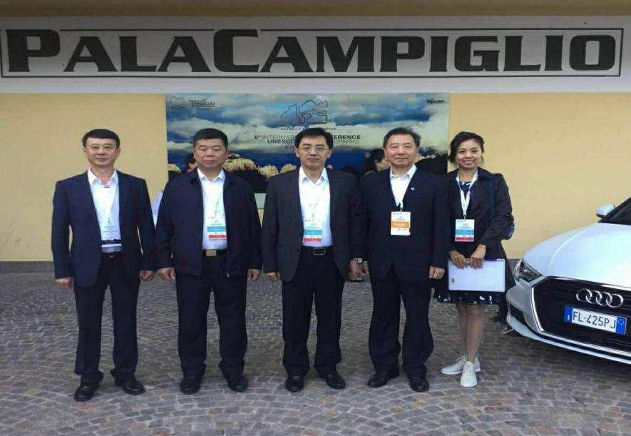

Gao Yan, the Mayor of Mudanjiang Municipal Government, led a delegation to Participate the 8th UNESCO Global Geopark Conference.

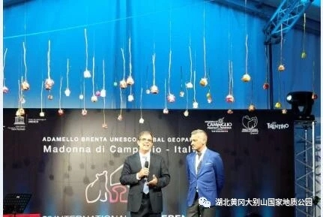

2.GEOPARK FIGURES
Number of Geopark staffs: 379 employees, including 11 geo-scientists.
Number of Visitors: 930,000
Number of Geopark events: 12 times.
Snow and Ice Dome • The 7th Winter Snow Carnival Festival, “Watching Festive Lanterns and Visiting Snow Forts” activity in the Lantern Festival, Outdoor crossing activities with the theme of “Ushering in Spring”, "Volcano Wetland" Cup International Marathon, "Jingpohu UNESCO Geopark Science Lecture", "Protect the Earth, Start with Us" Science Popularization Week, 2018 Mudanjiang Jingpohu International Marathon and "Healthy China" Series, " The Second Leisure Fishing Grand Prix", "Hot Balloon Camp Launch Ceremony", "Big Man of China Net Visiting the Jingpohu Lake", "4.22 Earth Day" The science knowledge lectures at the Crater spot, "5.19 China Tourism Day" The publicity of geological science knowledge.
Number of school classes conducting Geopark educational programme: 50.
The number of press releases issued by the Geopark: 629 articles (times) published on the traditional provincial and municipal media, and 566 articles (times) published on the web and new media.

3.GEOPARK ACTIVITIES
Key achievements in 2018
- Completed the repairing work of 2.2-kilometers trail from the East-Gate to the Villa Center. 2.Completed the construction of the Volcanic Exploration Hall, which is located on the north side of the underground forest scenic spot. The building area is about 800 square meters. It consists of five parts:“Walking into Jingpohu UNESCO Global Geopark, Unique volcanic geological relics, Volcanoes of the World , Feeling the photoelectric scene of the volcanic eruptions and The Colorful Natural. 3. Planting 50,000 plants, 40,000 perennial flowers, 3,600 shrubs, 1000 square meters of grass, and 100 landscape trees. 4. Completed the upgrading of the software and hardware facilities of the existing platform on the Smart Scenic Spot projection, and finished the repairing work of the maintenance breakpoints on line. 5.The UNESCO UGGp Management Committee strengthened the management of the geopark, accumulated 291 inspections and issued 13 notices of suspension. 6. “Lake responsible system” for full implementation, established the three-levels lake chief responsibility system of the commission, defined the functional responsibility and the scope of management and protection, formulated the working system. 7. Successfully completed the third revalidation work, and won the full recognition of the evaluating experts.
Contributions to GGN - Networking and Participation：
- Remittance to UGG for 2018 annual fee of 1,500 Euros. 2. Gaoyan, the Mayor of Mudanjiang Municipal Government, led a delegation to participate in the 8th UNESCO Global Geopark Conference held in Italy. During the meeting, he participated in the APGN Network Coordination Committee meeting, and he met with the Professor Nickolaos Zouros, the Executive Chairman of the UNECSO Network. 3.Signed the contracts of the Sister Parks with the Croatian Babuk UGGp, and the Yandangshan UGGp, and the Guangwushan-Nuoshuihe UGGp. 4. Participated the Annual Meeting of the UNESCO Global Geoparks of China in 2018, and exchanged the experience. 5. Completed providing the relevant materials and specimens of Jingpohu UGGp to Hong Kong UGGp, Danxia shan UGGp, Huangshan UGGp, Ningde UGGp and other parks of the CGN. 6. Visited the the sister park, the Shennongjia UGGp, shared the working experience. 7. Organized “the 2nd Volcanic Geoparks Forum in 2018”together with Leiqiong UGGp, Wudalianchi UGGp, Ningde UGGp and Yandangshan UGGp, and successfully applied for hosting qualification of the next Volcano Forum in China.
Management and Financial Status：
The Management Organization:
Jingpohu UNESCO Global Geopark Management Committee
The Financial status：The Financial status is well-off, with the income of tickets up to 37 million ¥ in 2018.
Geological heritage protection：
1. Implemented the “river-responsible system” and the “lake-responsible system” to improve the water quality and ecological environment of Jingpohu UGGp. 2. Investigated and restored the geological relics for the damage of the two flood disasters in summer.3. Field patrols, forest fire prevention, and community promotion.
4. Established popular science corridors in the scenic spots of the Villa Center, the volcanic crater, the waterfall village, the Xiaozhujia village, and the Dongjingcheng Middle School, to promote the knowledge of protecting the geological heritage. 5. According to the emergency plans of the geological relics, ecological protection, forest fire prevention and other resource protection ,conducted the joint law enforcement inspections 4 times, holed the training and the exercises for resource protection 4 times.
Sustainable Tourism (Geo-tourism)
Total of tourists is 930,000, geological tourism has boosted the local economy with 600 million yuan. There are nearly 200 farmhouses and more than 90 hotels and restaurants, and more than 5,000 people are directly engaged in the tourism service industry. More than 12,000 people indirectly engage in the tourism service industry and benefit from it.
The New education programs on protecting geological heritage, sustainable development and reducing the risk of the disasters.
Geoscience Popularization and Education Campaign Plan of the Jingpohu UNESCO Global Geopark in 2018 was formulated, and the Science popularization and Education of geological heritage and ecological environment protection, other science popularization activities were also carried out such as “4.22 World Earth Day”, “International Biological Diversity Day”, “6.5 World Environment Day”, “International Nature Disaster Mitigation Day”.
Cooperated with the Mudanjiang Normal University to implement the "Science and School Cooperation", signed the science education base agreement and built a popular science exhibition corridor on the campus. Cooperated with the Eleventh Middle School, the Ninth Middle School, the Youlan Musical instruments Hall, and the AngLi Foreign Language School to conduct geological science lectures and held the research tours. In the "Beautiful Village" activities of the Xiaozhujia Village community in Ning'an City, the science education of environmental protection in geoparks and the science education of natural disasters were carried out.

Strategic Partners
The Jingpohu UGGp has carried out research and protection of geosciences in cooperation with Hydrogeology and Engineering Geology Prospecting Institute of Heilongjiang Province. The geopark has also established professional practice and training bases in collaboration with the China University of Geosciences (Wuhan), the Geography and Geography Remote Sensing Science and Technology School of Beijing Normal University, the Mudanjiang Normal University, established “popular science education bases” in collaboration with Mudanjiang Normal University and Dongjingcheng Town Middle School in Ning'an City. The "Beautiful Village" project has been co-built by the Jingpohu UNESCO UGGp and Xiaozhujia Village in Ning'an City. The geoscience tourism is carried out in cooperation with more than 120 tourism agencies including the CTRIP, the CYTS, the Northeast Scenic Spots Alliance, the top 100 travel agencies and so on. The network promotion is launched in collaboration with Tourism and Development Committee of Heilongjiang Province, the Propaganda Department of Mudanjiang Municipal Party Committee, the Mudanjiang Municipal Development and Reform Commission, the Mudanjiang News Media Group, 17 mainstream online media and three self-media.
There were three times continuously 6 fragment broadcasts on CCTV 2 and CCTV 13, and the program named "Wonderful Places in Summer", special shooting for the Jingpohgu UNESCO UGGp, broadcasts on CCTV 2 since 7,July to 10,July.
Continuous and comprehensive publicity together with the platform of the Department of the Municipal Party Committee, with the Today's Headlines and the Longguang Media of Heilongjiang Province.
Promoting activities
We held the spring and summer tourism sharing conference, the tourism promotion conference and key distributors in Harbin, Beijing, Shanghai, and Guangzhou, we participated in the “China-Korea International Tourism Exhibition” , the “passion and ice”, and the “Hong Kong, Macao and Taiwan theme publicity activities” those organized by the Ministry of Culture and Tourism, we participated in the “Northeast, Yangtze River Delta Tourism Scenic Spot Team Direct Mining Platform” and the “Haikou City Scenic Area Association and Northeast Tourism Scenic Area Alliance” organized by the Northeast Tourism Scenic Area Alliance and the Yangtze River Delta Tourism Scenic Area Alliance. The Yangtze River Delta Tourism Scenic Area Alliance is a source of mutual customer and tourism cultural and creative products exchanging meeting, we participate in the 25th International Advertising Festival Heilongjiang Tourism Exhibition, "2018 China Tourism Industry Expo and the 23rd China Northern Tourism Trade Fair", we participated in the summer tourism promotion conference organized by the Heilongjiang Tourism Commission, the five-city tourism promotion conference organized by the Ice and Snow Crown Tourism Scenic Alliance and the Beijing Tourism Special Promotion Conference organized by the Mudanjiang Tourism Commission, we participated in the Heilongjiang Eastern Tourism Industry Alliance, we took part in the “Spring in the North, Carefree in Heilongjiang Province”, the “Summer Resort, Carefree in Heilongjiang Province", the theme promotion, (Russia and China) tourism products (Fuzhou) promotion, we took part in the“ Winter tourism promotion in Mudanjiang City" at Dongguan City, we took part in the “Vitality Dashing” the Guangzhou push promotion event organized by Guangdong Satellite TV, we held the Jingpohu UNECSO UGGp theme scenery photo exhibition and tourism promotion meeting in the Yuyuan Garden of Shanghai City .

4.Contact Person:
Manager: Dezhi Sun Email: jphzpg@163.com

Geologists: Jiangfeng Li , Xuewu Zhou Email: jfli0524@163.com

